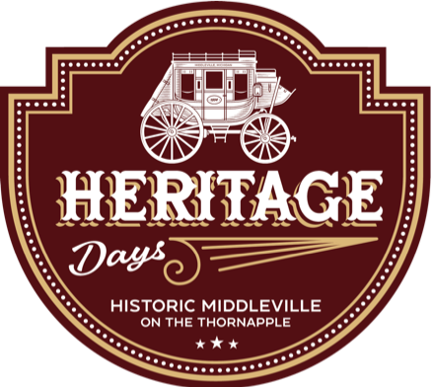

VENDOR APPLICATION

Join us Saturday, August 24th for a Makers Market during Middleville’s annual Heritage Days Festival! This family friendly event will include live music, children's games, a parade, classic car show, parade, historical exhibits, and much more.

Jury reserves all rights to approve or deny applications and may require that any items that do not meet jury standards or that are deemed not in keeping with the spirit of the event be removed from display. Reminder this is a family friendly event thus all items sold must be appropriate for all ages. The show will be held in Sesquicentennial Park under the pavilion, and on the riverwalk in Stagecoach Park. Vendors set up alongside their preassigned allotted space. All vendors on the riverwalk section will need to bring their own canopy/tent. Set up will begin at 7:45 AM on Saturday morning and all vendors must be set up by 8:45 AM. The market will run from 9:00 AM-3:00 pm. All booths must be torn down by 4:00 PM. Early departure is not permitted. The Main Street parade will start at 10:00 AM and all other activities will begin at the conclusion of the parade. Cost is $30 per 10 x 10 booth space. Three (3) photos of your booth space and items for sale must be submitted with your application and will be used for promotional purposes.

Payment MUST be made prior to the show. Cash or checks are accepted. Make checks payable to **Middleville DDA** and send with application to: **Middleville DDA, PO Box 69, Middleville, MI 49333**. Or drop off at the Middleville Village Office Located at 100 E Main St.

VENDOR Market

VENDOR APPLICATION

Name: ___________________________________________ Business Name: ________________________________________ Address: __________________________________________ City:________________________ State:_______ Zip:_________ Phone:____________________________________________ Email: ________________________________________________ Website: __________________________________________ Sales Tax ID: __________________________________________ Description of goods to be sold:___________________________________________________________________________ __________________________________________________________________________________________________________ Section Availability: Check the section that best applies, and check only one:

____ Arts and Crafts Makers Market ____ Antique/Collectable and Repurposed Items

VENDOR MARKET POLICIES

* Be courteous and respectful to everyone. No smoking or vaping are allowed at any time. Any inappropriate behavior may result in immediate expulsion from the market without refund.
* Vendors must be set up and open during show hours.
* Keep space clean, neat, and orderly during market. Remove all items within one hour after the market closes.
* All items sold must be appropriate for ALL ages.

All Vendors are required to have and display a copy of all federal, state, and local licenses appropriate for their business. Sales tax is the responsibility of market vendors. This is not an assumed responsibility of the Middleville DDA or the Village of Middleville. You are responsible for protecting your own assets and are encouraged to carry your own liability insurance.

HOLD HARMLESS CLAUSE: In consideration for being accepted as a Vendor, to the extent allowed by law, Vendor hereby agrees to defend the Village of Middleville and the Middleville DDA, including their respective agents, against any claim of liability, including but not limited to claims based on their own negligence, even if such claim is false or fraudulent, and to defend the Village and DDA against any claim or liability that may arise as a result of any occurrence in, at, or on the Vendor Fair or the grounds on which the Fair is held. Vendor further agrees to indemnify, defend, and hold harmless the Village and DDA against any and all liability, losses, or damages or any expenses whatsoever.

I have read and agree to comply with the Vendor Market Policies in their entirety. I hereby grant permission to be photographed, voluntarily and without compensation, understanding that the same is intended for publication by print & digital media, newspaper, television, or video. If the undersigned is an agent or representative of Vendor, he or she attests to possessing the authority to sign this Agreement on behalf of Vendor.

Print name: ________________________________ Signature: Date: _____________________  
Make checks payable to **Middleville DDA** and send with application to: **Middleville DDA, PO Box 69, Middleville, MI 49333**.

For questions or more information, contact Gretchen at: gretchen@middlevilledda.org or call/text: (269) 241-1170. OFFICE USE ONLY: Amount Rcvd: ________ Check #_______ Date: ____________ Initial:__________ Booth #________