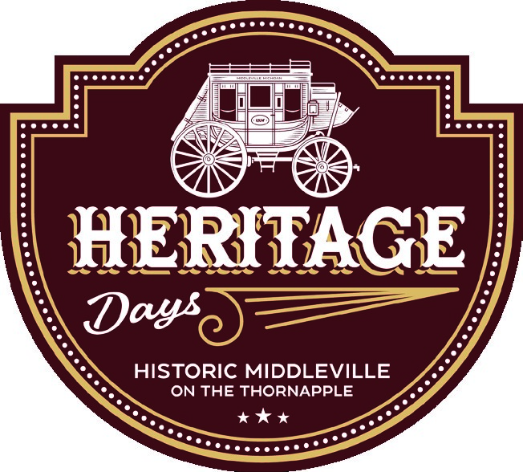***Charlie Pullen Memorial***

# *Car Show*

# What: Show off your classic ride as we celebrate the legacy and be entered for a chance to win a trophy! When: Saturday, August 24th, 2024 11:00am -2:00 pm (Participants may ride in the parade at 10:30am and arrive to the lot behind the Village for the car show at the end of the parade) If you wish to drive in the parade, please contact Makenzi Peters [mpeters@carvethvillage.net](mailto:mpeters@carvethvillage.net) Where: East Main St., Middleville, MI 49333 Cost: $10 (make checks payable to Middleville DDA)

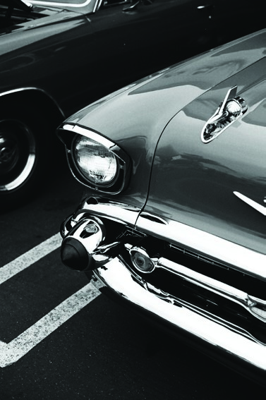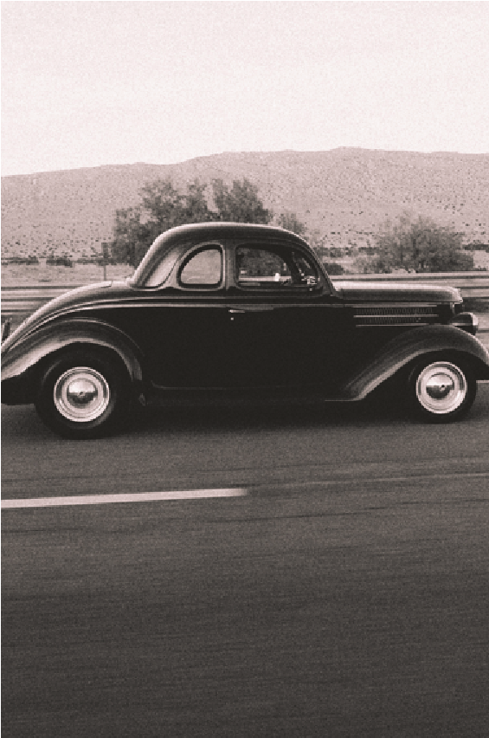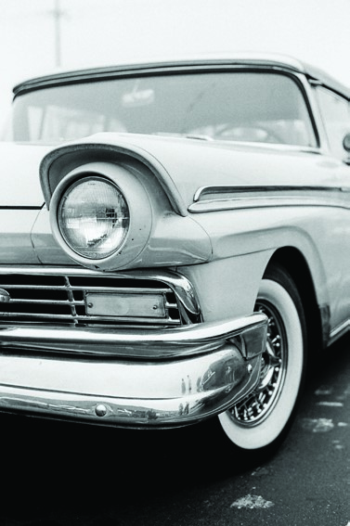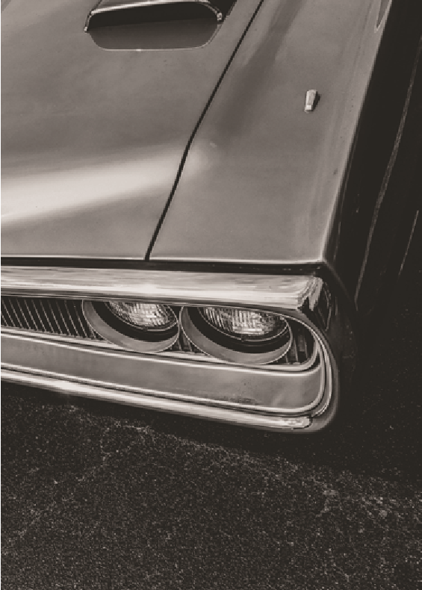

**- - - - - - - - - - - - - - - - - - - - - - - - - - - - - - - - - - - - - - - - - - - - - - - - - - - - - - - - - - - - - - - -**

***Cruise-In Registration Form***

Please Pre-Register! Space is Limited!

Name of Vehicle _________a_____________________________________________________________

Owner Name _________________________ Contact Phone # ______________________________

Address: ____________________________________ City___________ State _____ Zip ____________

Email: ___________________________ Make: _____________ Model: _____________ Year: _______

For mailing applications:

P.O Box 69, 100 East Main Street  
Middleville, MI 49333

Questions? Contact. gretchen@middlevilledda.org